**Events Page Design**

**Elements:**

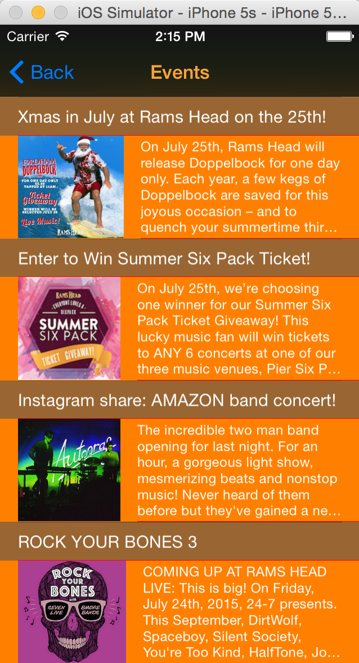Title: Events, orange

Navigation Buttom: “Back”, blue; back to last page(Menu)

Title Row(even):

White text, event name, font15

Content Row(odd):

Image: left

Content: white text, font 12

Table:

Black background, red separator